**PLAYING WITH FILES :**

2. Copying the date from file1 to new file2

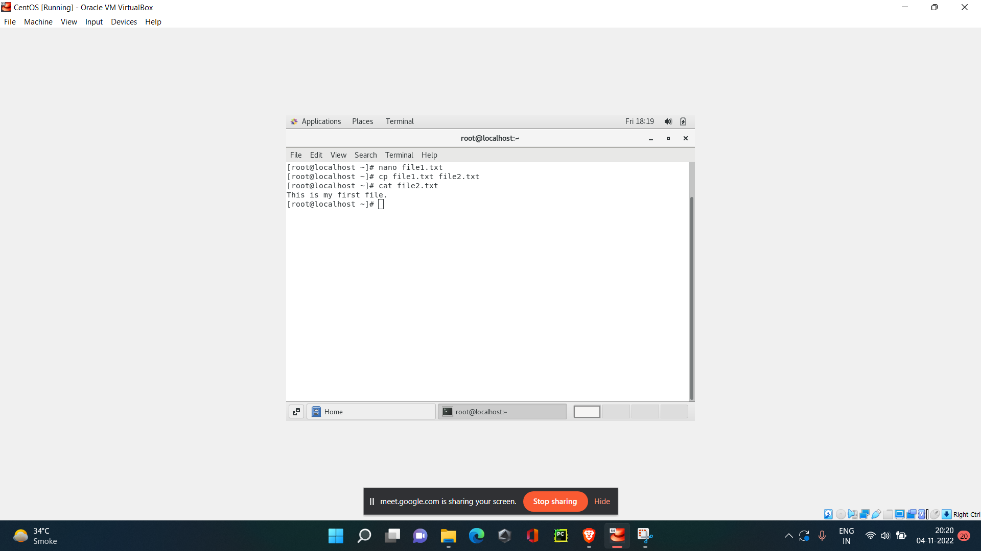

3. Now we will move the file2.txt to new folder /home

* Yes , the file exists in home directory.

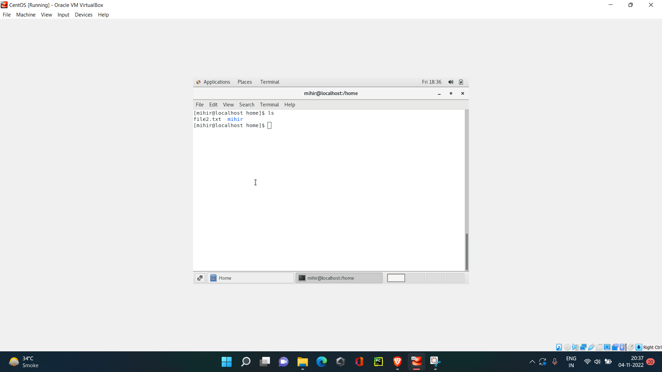

4. The “>” is the output redirection operator used for overwriting files that already exist in the directory. While, the “>>” is an output operator as well, but, it appends the data of an existing file. Often, both of these operators are used together to modify files in Linux.